Debugging Notes

Wednesday, February 19th:

* I realized the solution was infeasible because there was nothing to make the vehicles leave the depot. Wrote a constraint to ensure vehicles leave from the depot (line ~475)
* Converted theta from degrees to radians
* Created “Demand_TEST” csv with demand values of only 18,000kg [later changed to 15,000kg]
* Term2, term3, term4, and term5 all validated. They all seem to yield reasonable results given the objective function outputs in my tests here.
* Constraints 1.1 and 1.2 validated as well as 2.3 and 2.4

Saturday, February 22nd:

* Added the time constraints. It took 8 hours to run and got a feasible solution. However, I notice some issues. Some customers are visited multiple times, which should not be possible because demand may be satisfied with only one visit.
* It appears that the time constraint is working. However, the connective of tours constraint may not be. Vehicle all at least start once from the depot (node 20), but then it seems like they are able to skip over to any arc somehow. See example:
* 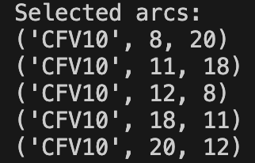
* It appears that I have no *per-vehicle* flow conservation, which is why this is happening.
* I took out the time constraint and added this new constraint. It appears to have worked:
* 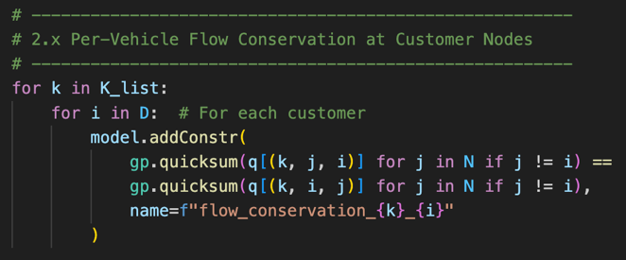
* Now I am going to try and integrate in the vehicle load updating. So when a vehicle gets to a customer it should be depleted and return to the depot. In this case I did not activate the load replenishing constraint, so a lot of vehicles should be used (because each vehicle can only drop off one load before returning).
* There was no bug when I integrated constraint 2.4 (vehicle begins fully loaded).
* With the updating constraint it was taking too long, so I added the following:
* 
* Solution time still taking too long. May need to run this overnight. **Will come back to this**. Remember:
  + - After 45 minutes no feasible solution was found.
    - “term2” was the only active objective function value (acquisition costs only)
    - “Normal” values for CFVs/HGEVs (165,000/400,000)
    - Active constraints:
      * Routing: 1.1, 1.2, 1.3
      * Capacity and flow: 2.3, 2.4, 2.5, 2.6, 2.7
    - There may not even be a feasible solution with this constrain set-up. I have read that just because it complete the pre-solve does not mean that there is a feasible solution. I may need to figure out how to test 2.6 and 2.7 separately, or with a scaled down set of customer nodes.
* Alright, now I need to start looking into testing the emissions objective function
  + I have decided to take out emissions related to HGEV recharging, as carbon caps and taxes do not typically work in this way. The carbon tax imposed on HGEV recharging-related emissions would be included in this.
  + “term9” has been removed
  + Integrating “term1” outputs a massively large negative number and is bugged.
  + From my experience with the continuous updating of the load being computationally expensive, continuous updating of the vehicle charge would also likely be extremely taxing. Now, the question that occurred to me: does continuous updating of the charge actually add that much value in this case?
    - No, it does not add much value, since in this scenario I assume that HGEVs are fully charged while being unloaded.
    - Therefore, the real-world fidelity would be practically the same if I just imposed a range restriction on HGEVs. The maximum range available to them could be updated if they happened to unload at a charging station. Maximum range would be 600km (a reasonable assumption).
    - Therefore, I reformulated the recharging cost function to just be r*h*d[i,j] for each HGEV. This is the new “term1”:
    - 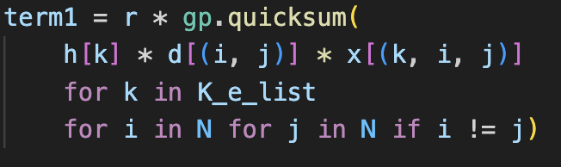
    - The terms Rk and Lk could also be eliminated in this case.
    - After this update, “term1” was fixed.
    - However, I have also read elsewhere that continuous updating of variables should not be to computationally expensive, so **I may undo this decision later**, if I can figure out how to update the load correctly. I think prospective editors might frown on this decision.
* After the emissions objective function I need to test the HGEV-related cost terms.
  + I will remove all references to “mu.”
  + “term6” has also been removed
  + In this case HGEVs would be viewed more favorably, but perhaps an editor might view this as less comprehensive? Including “mu” might also increase the novelty of my paper.
  + Actually I changed my mind. Anyone can see that there are not “0” emissions associated with recharging. I have added “mu” back. The emissions calculation is now aligned with the calculation of “term1” as used to calculate electricity requirements for recharging
  + Now to test “term7” and “term8”
  + The model runs but it seems like it judges CFVs to have lesser emissions, which is not right. I need to investigate the formulation of “term7.” The output was only 1.97kg of CO2. If I include only “term7” to be minimized it says HGEVs emit 51.22kg of CO2. This would also impact “term5” since they are calculated the same.
    - 
    - Wc is 12,500kg… OK
    - Phi is .00277, a very small value
    - Sigma is 1.56… OK
    - F_param is .2… probably OK
    - I_param is 22… OK
    - E_param is 12.9… OK
    - Lamba is .000031, a very small value
* 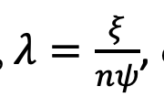
* Xi is 1 (unitless)
* n is 44 (kJ/gram)
* psi is 737 (for converting grams/s to liters/s)
  + So it probably should be *1,000*60*60 in the numerator to go kilograms/s to liters/hour…
* **Perhaps there is something wrong with my units**. My time matrix is in hours, my fuel consumption assumptions are based on liters, and my weight of CO2 (and other variables) is in kilograms. My velocity matrix would also be in km/hr.
  + - Omega is 2.79… OK
    - So my source for this equation (Demir et al., 2014) used meters and seconds as their units. Perhaps I need to convert my assumed values to align with the units I use (kilometers and hours).
    - Here are the parameters I believe I need to work on:
    - 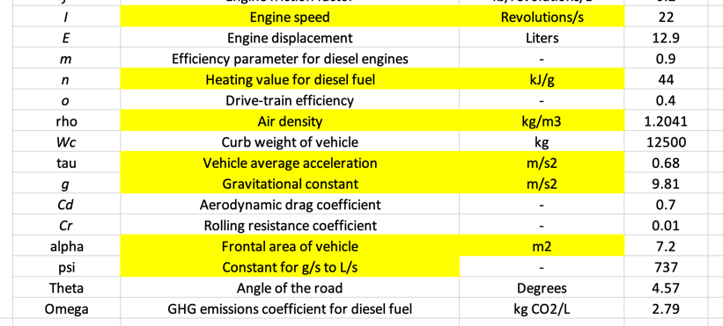
    - I believe I have calculated the correct values here:
    - 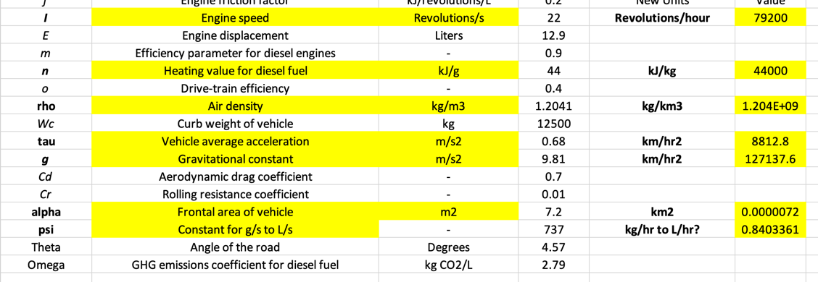
    - Now I will sub these values in
  + Ok, after running the model again to minimize emissions the HGEVs “won.” I can tell that “term8” is returned the correct number by doing a basic calculation.
  + No I will raise “mu” so high that a CFV will have to be chosen…
  + The diesel emissions came out to ~20,000kg with a distance of ~155km. This is much higher than would be reasonable. Given this distance I calculate that only about ~140kg of CO2 emissions would have been the expected amount (given a certain reasonable fuel efficiency assumption).
  + After some more adjustments there are about 30000kgs of CO2 emitted, but my manual calculations indicate a good ball park would be about sixty times less than that.
  + I realized my curb weight estimate was too high, this was reduced to 6,700kg (the actual weight of the truck I am using) and now CO2 emissions are down to ~20,000kgs (10,000kg due to curb weight, 10,000kg due to load effect)
  + A reasonable emissions just for the curb weight portion would be *around 300kg*.

Sunday, February 23rd:

* Overnight I ran the model to minimize costs with the load updating constraints turned on. After ten hours Gurobi had not found even one feasible solution.
* Also, yesterday I got the CFV CO2 amount down to about 50% of the original high value by tuning various parameters to better suit the characteristics of the truck that I chose. I will continue this now.
* Why did the original authors (Demir et al., 2014) us a fuel to air mass ratio of 1? References I found online tell me it is much lower at ~.07. I have adjusted this.
  + - * Heywood, John B. Internal Combustion Engine Fundamentals. McGraw-Hill, 1988
    - Now I get 824 kg of CO2 emissions over 277km. That could be compared against a value calculated from fuel efficiency number (2.5km/L) of about 300kgs. In this case the load effect is calculated to be the higher, which doesn’t seem right.
    - The angle (theta) value that I have been using is 4.57 degrees… That seems a bit high for a highway and long-haul routes. Some research I have done indicates that a more accurate value would be between 0 and 1 degree. References:
      * Ontario Ministry of Transportation (MTO) design manuals outline maximum and typical design grades, which indicate that many major highways are designed with very low slopes.
      * Transportation Association of Canada (TAC) guidelines on geometric design for rural highways also support the idea that, over long stretches, the effective average grade is minimal.
    - I am going to use a value of .57 degrees for now… This was recommended by ChatGPT, so I will need to go back in and find a better reference later. Now I get a CO2 emissions value of about 500kg which could be benchmarked against 300kg (so pretty reasonable!). I also realize that my load updating function is not working right now, so it is counting the trailers to always be fully loaded. If the load effect were halved (as it should be) my CO2 emissions would come out to under 400kg, so I am good with this for now. However, the load effect is still intuitively a bit high – will need to come back and visit this later.
      * One thing I may need to do is come back again and convert all of the units back to “normal.” It would be strange to publish a paper with my acceleration units in km/hr2 or vehicle frontal area in km2, for example – editors may take issue with this. My time and distance values would need to be converted to seconds and meters respectively.
    - I forgot to divide by 2,000 in term5 (diesel emissions costs) because the tax is levied per ton. When I fixed that I got a reasonable cost result for diesel emissions.
    - Now I turn to fixing constraints 2.7, 2.8, and 2.9 (load updating and returning to the depot when empty).
      * I think my current Big M constraints are slowing down the solve too much. I will try some other approaches.
      * Alright, so here is what I put in instead of the Big M constraint and Gurobi is able to find feasible solutions.
      * 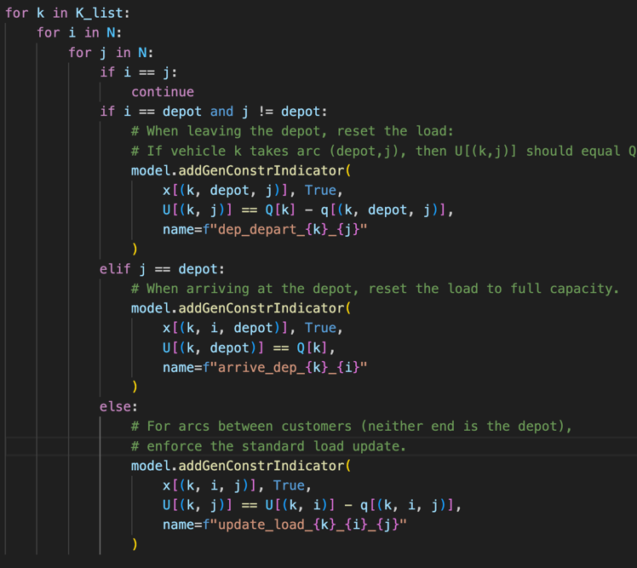
      * Here is a breakdown of what it does:
        + Load reset at the depot (first and second part): When a vehicle leaves the depot, it starts at full capacity (minus the delivered load on the first leg), and when it returns to the depot, it is reloaded to full capacity. This mechanism allows for multiple trips without having to carry over residual load from one trip to the next.
        + Continuous load update between customers (third part): For arcs between customer nodes, the load is updated in a sequential way.
      * I have also added these two constraints to eliminate subtours, which is another problem I was having:
        + 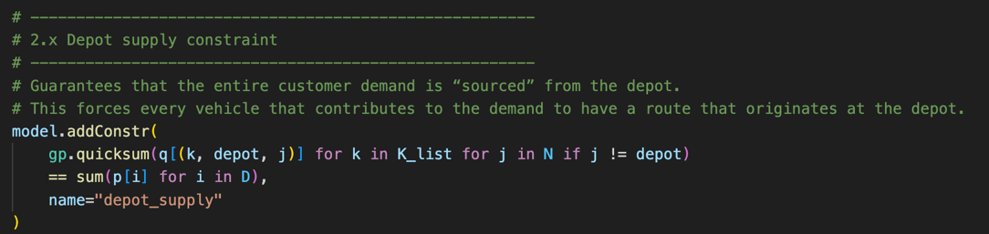
        + 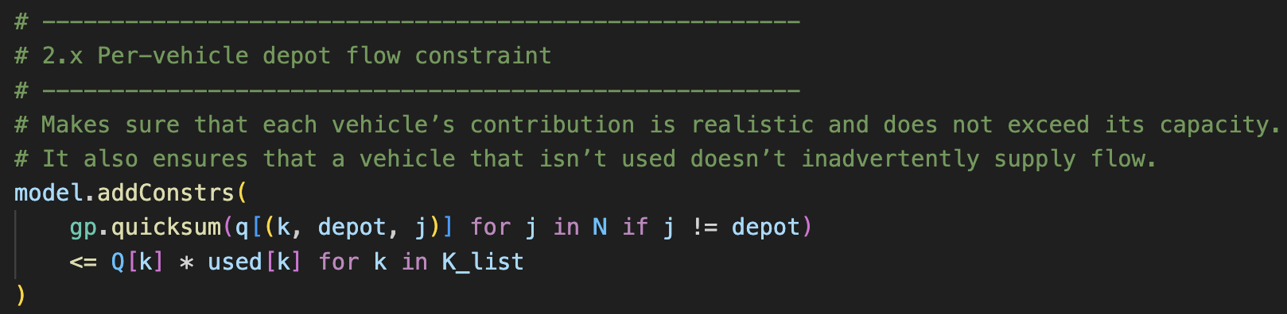
      * OK so I tested this all together and some vehicles took multiple tours (trips from the depot🡪customer🡪depot🡪customer🡪depot) which is a good sign.
      * However, it activated all of the vehicles, which doesn’t seem right. I also need to update my primary demand spreadsheet because when I was updating the emissions calculations I went from assuming 100% full loads (18,000kg) to 83% full loads (15,000kg). For now I will bring the load back up to 18,000kg.
      * When I run it now though it is wanting to acquire a lot of vehicles. One would think that it would actually just want to acquire a singular CFV and send it to deliver everything (and not pay the cost of acquiring any more vehicles)… I need to investigate why this is.
      * When I increase the load capacity to 180,000kg the vehicles are all still going back to the depot after every trip. This should not happen, as when they drop off a load to a customer there is still plenty of load left to continue on to the next customer without going back to the depot.
      * With my updates it keeps wanting to send out multiple vehicles, which shouldn’t be the case. It is taking a while to troubleshoot this.
      * Alright it was fixed! I had to create a new variable to track deliveries. Now, vehicles are stopping at different locations (instead of just alternating between depot and customers).
      * However, I notice that some vehicles are dropping off more load than they need to, overfilling their customers. Maybe that is because I stopped Gurobi before it could find a more optimal solution (50% gap), but maybe it’s a bug. I will need to come back to this.
      * For now, I am going to activate the time constraint again and let everything run (probably overnight) to see what happens.
      * Wow, I added the time constraint and it has already started to find feasible solutions after a few seconds. Although I think it did that last time too, but just took forever to close the optimality gap (I remember it was stuck at 20% for a long time).

Saturday, March 1st:

* Ok, I ran the complete problem I had (time, load updating, return trips, etc.) over the last week. It ran for several days, but could not get to full optimality (6.6% gap). I ran out of memory after a few days. I have another file where I have saved this output.
* Here is the punch list for this weekend:
  + ~~Clean up the code. There are some sections that are unused.~~
  + ~~Figure out how to stop customers from being overfilled.~~
  + ~~Verify connectivity by printing the exact order of vehicle trips (now the list is in alphabetical order).~~
  + ~~Verify that vehicle load is reduced when it actually makes a stop (haven’t done this yet). This is important because fuel usage is linked to vehicle load.~~
  + ~~Change all of my units to be m/s and so on.~~
  + Potentially add a trip index that could cover multiple days (years) of truck trips.
  + ~~Update and activate HGEV charge updating constraints.~~
  + ~~Update demand files to include the 83% truck load assumption I decided to make.~~
  + Look for code simplification opportunities to improve efficiency.
    - ~~I still have one BigM constraint left. These appear to increase time significantly~~
    - I may be able to remove the integer variable ‘used[k]’
    - Maybe constraint 1.2 (conservation of routing) could be removed because this constraint is naturally enforced by the load updating constraint
* Customers being overfilled:
  + Ok. It turns out customers weren’t being overfilled after all. I think this was just an error in how I was printing out the results (summing of q[(k, j, i)] rather than delivered[k, i]).
  + This is resolved.
* I verified connectivity of tours as well as load reduction upon making a stop.
* I added constraints for vehicles being recharged at the depot and for ensuring that HGEVs reserve enough charge for a return trip (plus margin of safety).

I noticed that the operating costs for HGEVs were coming out as somewhat higher than for CFVs… I think this means there is something wrong with my assumptions.

* + After a bit of research I notice that my recharging cost assumption (USD/kWh) is a bit high.
    - <https://www.timetoelectrify.ca/electric-car-charge-price/>
    - I am going to use the mid-peak cost assumption (.1607 CAD or .11 USD per kWh)
    - This is a 75% reduction based on what I had initially (.45 USD/kWh). This will make a bit impact
  + Also, I notice that I could calculate operating costs more efficiently (without uploading a csv).
    - Fuel prices in Toronto: <https://ycharts.com/indicators/toronto_on_average_retail_price_for_diesel_fuel_at_self_service_filling_stations>
    - I will use a fuel price assumption of $1.14USD/Liter (based on $1.65CAD/Liter, an average value over the last 12 months)
    - 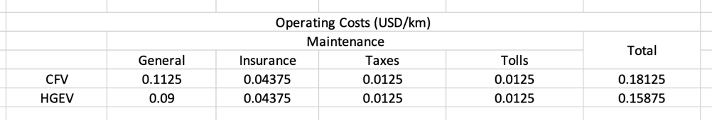
    - I will have separate objective function terms for the following:
      * + Recharging costs
        + Diesel fuel costs
        + General operating costs (see the table above)
  + Also, I notice that I should link my CFV costs with the fuel consumption model that I created for tabulating CFV emissions costs.
    - I have now split this into two different objective terms
    - 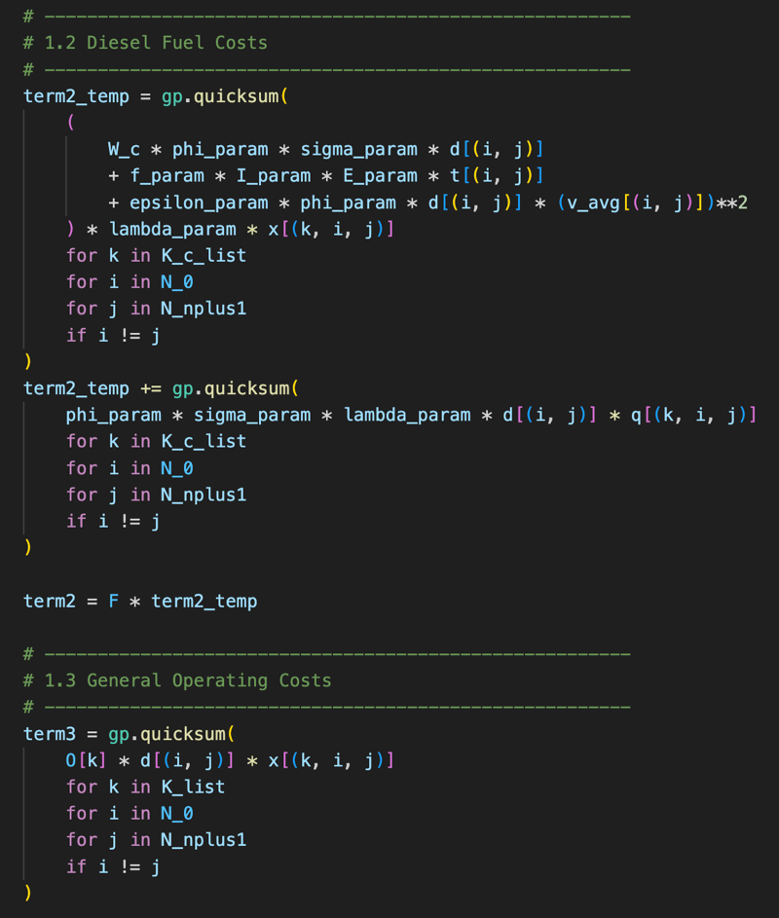
  + Now with all of these updates the model appears to be running well…
  + Let’s compare the outputs (these runs were terminated with a fairly high optimality gap to save time)…
  + Run as usual:

Selected vehicles: ['CFV17', 'CFV19', 'CFV20', 'CFV6']

Total cost: 662544.2899819791

Recharging costs: 0.0

Diesel fuel costs: 2066.755120315809

General operating costs: 421.84125000000006

Acquisition cost: 660000.0

HGEV infrastructure cost: 0.0

Diesel emissions cost: 55.69361166324704

Total distance traveled: 2327.4000000000005

* Run will obscenely high acquisition cost for CFVs:

Selected vehicles: ['HGEV10', 'HGEV14', 'HGEV15', 'HGEV18', 'HGEV7']

Total cost: 7000676.5474

Recharging costs: 292.62640000000005

Diesel fuel costs: 0.0

General operating costs: 383.92100000000005

Acquisition cost: 2000000.0

HGEV infrastructure cost: 5000000.0

Diesel emissions cost: 0.0

Total distance traveled: 2418.4000000000005

* Things to check:
  + Compare truck fuel efficiency based on “napkin math” (i.e., reasonable kilometer per liter assumption):
    - With a cost of $2,066 the vehicle traversed 2,327km
    - With my cost assumption of $1.14/L that means the vehicle consumed 1,812 liters
    - This would be a fuel efficiency of 1.28km/L (or 3mpg)
    - This is too low to be reasonable really. Something is still wrong with my instantaneous fuel consumption model.
    - Firstly I will reconvert all my units back to “reasonable” units and come back to this. Hopefully this will fix the erroneous value.
  + Compare total operating costs for CFVs versus HGEVs:
    - CFV (fuel plus operating): $2,066 + $422 = $2,488
    - If the CFVs were twice a fuel efficient (after tuning my model, for example) this value would be $1,033 + $422 = $1,455
    - HGEV (recharging plus operating): $293 + $384 = $677
    - This represents 73% (in the first case) or 53% (in the second) improvement. Benchmarked against a bit of research this seems reasonable (for either case really).
* Alright well I would say I have solved my initial problem of having too high of operating costs for HGEVs. Although I will need to return to the CFV part as I discovered.
* Now to move on to investigating the battery updating a bit more…
  + I am adding in the concept of customers that are also recharging stations.
  + Ok, I did that and ran it. Charges are being appropriately updated at the depot, at customers, and at customers that have charging stations.
  + Hum, so I ran it with printing out some additional information and it appears that some HGEVs are taking unnecessary subtours. Let me try changing the settings…
  + Still doesn’t work. Let’s see if this happens with CFVs as well.
  + It is happening with CFVs just the same. I wonder what is making it so that sometimes the vehicles in not delivering.
  + It could be because I am not solving to full optimality. I will ensure to run it for a while when I go to the gym (so it can fully solve). But I remember when I did this with the HGEVs it did got to full optimality and I had the same problem.
* NOTE: one thing that appears to be going wrong is that when I run the model without any time constraints active it is selecting multiple vehicles to deliver to customers (for CFVs and HGEVs). This is counterintuitive because, since there is no concept of time, only one vehicle should be able to do everything. I need to circle back to this eventually to figure out why this is happening.
  + Ah, I figured at least one thing out. My expanded infrastructure constraint is partially to blame for this. The current constraint says that if any HGEV travels 600km *total* then the expanded infrastructure should be activated. But what I mean to say is in just one tour. This should be fixed now. Although I will need to check
* I have removed the last BigM constraint as I added a cumulative trip distance constraint which is linked to the expanded infrastructure integer variable for HGEVs.
* Alright, I added a minimum delivery constraint to ensure non-zero deliveries. This appears to have eliminated unnecessary subtours.
  + Actually it didn’t there is still a problem.
  + Actually I added the constant of “9,000” in front of the constraint and this appears to have worked. Will need to verify tomorrow.

Sunday, March 2nd:

* Alright, I ran the whole bi-objective model and I seem to be getting reasonable results for the most part. Partial deliveries are working well, and there are no weird subtours. I notice extending the time window to 22 hours (from 12 hours) made a big difference in the solution time.
* The one things that doesn’t seem right is related to my emissions output.
* I think now is the right time to convert all of my units. I will also use this as an opportunity to update all of the demand values.
* Before I change all this I am going to archive the current version of the model (“3_1.py”).
* Let’s summarize what I need to do:
  + ~~Convert the distance matrix to meters~~
  + ~~Convert the time matrix to seconds~~
  + ~~Convert current demand and truck capacity to *.833333 of the current amount in all cases~~
  + ~~Convert general operating costs to price per kilometer to price per meter~~
  + ~~Convert energy consumption from kWh/km to kWh/m~~
  + ~~Convert the time window to seconds (from hours)~~
  + ~~Convert the trigger for z_i^k and HGEV_exp from km to meters~~
  + ~~Convert all highlighted values in the table below back to the values on the left-hand side~~
  + 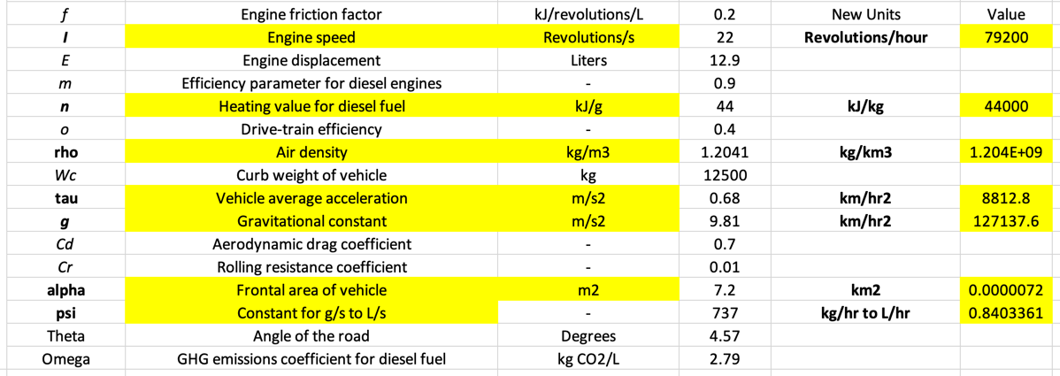
* I realized I was converting to metric tons of CO2 wrong – will need to remain vigilant of this when I go look at the results
* Alright, I have made all of the relevant changes I listed above. Let’s see how the model runs. I am going to run it without the time constraints so it goes faster.
* Results from the first run:

Best objective 6.605873933896e+05, best bound 3.305915569240e+05, gap 49.9549%

Total cost: 660587.3933896212

Recharging costs: 0.0

Diesel fuel costs: 170.1393966140929

General operating costs: 408.0843749999999

Acquisition cost: 660000.0

HGEV infrastructure cost: 0.0

Diesel emissions cost: 9.169618006991112

Total distance traveled: 2251500

Total diesel emissions: 164.6547835706517

Total diesel emissions due to curb weight: 217.4126333873113

Total diesel emissions due to load effect: 164.6547835706517

Total HGEV emissions: 0.0

* So it chose 4 CFVs to go a variety of routes. The routes are connected and there are no unnecessary subtours.
* The general operating costs seem right.
* Total distance traveled (2,251km) seems reasonable given past results
* Fuel costs seem very low. I will investigate this.
* There is something wrong with my diesel emissions calculations as well – this could be something wrong with how I am printing the output, will have to check
* Previous authors have used a xi value of 1. This is common so I think it may have been a mistake to change this originally.
* I realized my engine speed was wrong. Changing to 15 revolutions/s
  + <https://more.brandt.ca/getattachment/Peterbilt/New-Trucks/Engines/2017-MX-11-Spec-Sheet.pdf.aspx/?lang=en-CA>
* Now I am getting a value of just over $2,400USD. The current model tuning is outputting a very fuel inefficient result.
* I think I will split up my objective function term2 into two different terms (one for the curb weight factor and the other for the load effect). This will make it easier to see what is causing the high amount and make it easier to tune the model. I will do the same for GHG emissions.
  + Alright, I rearranged my model outputs so they are a bit more instructive.
  + I also realized I had accidentally switched engine thermal efficiency and mechanical drive-train efficiency. This made a small difference.
  + Updated aerodynamic drag coefficient.
  + Updated “psi” value to one that is more accurate (some research revealed that the 737 value that I was using is likely not correct). This reflects diesel fuel rather than gasoline.
  + Ok, so I realized previous authors I have been relying on used a fuel-to-air ratio of “1” merely as a simplification for their model. In real life the value would be much lower. I am going to use a value of .04 and then tune the model accordingly.
    - This may have been the source of my problems all along.
  + Anyways, it took a while but I finally got this dialed in.
* The final biggest problem I seem to be having is figuring how to activate HGEV_exp appropriately and tying it into the charging stations, which should be turned “off” if HGEV_exp is 0, but “on” if it is 1. This will be my main focus next weekend.

Saturday, March 8th:

* Here is my punch list for this weekend:
  + Resolve my issues with the conditional activation of the expanded charging network
  + Test edge cases or other conditions that I haven’t tried or verified before:
    - Verify time updating and that the constraint is satisfied
    - Add an additional customer that is very far away to force HGEV_exp to 1, and ensure in that way that it is working properly
    - Separate my diesel emissions terms in objective 2.1 for ease of interpretation of the outputs. Also potential do this for constraint 1.7
  + Figure out why multiple vehicles are being selected when I remove the concept of time
* Note: I was able to index the whole problem over multiple trips ‘z’ at the end of last week. I did get a feasible solution, however, it did not account for the appropriate number of vehicles being acquired (i.e., the cost function did not trigger it appropriately)
* Now I have been working on the recharging issue.
  + I have made new nodes that will be assigned as “ghost customers.” They have zero demand, but can serve as a charging station if HGEV_exp is activated.
  + Alright, this seems to have worked! I will need to come back and test this. For now I think I want to start working on the greedy search heuristic.
* Greedy search heuristic
  + After about an hour I think I have successfully set this up.
* ALNS
  + Got the initial code written, but it obviously does not work.

Sunday, March 9th:

* I think I am going to work on my PowerPoint mostly today

Saturday, March 15th:

* Today I am going to troubleshoot the only remaining bug that I know about, which is that Gurobi is thinking two vehicles would be the best option even when there is no concept of time. After I fix that I am going to just work on my PowerPoint.
  + Ahhhh, I see the source of my problem now…
  + Delivered[k, i] can only take on one value. So in effect each vehicle can only go to customer i once.
  + Alright wow solving this problem is going to be so much more difficult than I thought.
  + I will need to add a visit index. Combined with a trip index later on this is going to astronomically increase the size of my problem.
  + Alright so I didn’t add a visit index. Instead I was able to successfully integrate network expansion to fix this bug.

Sunday, March 16th:

* Working on adding a tour index to capture multiple days. I did this and it appears to be working so far.
* Alright so an important finding that I should note down: in the test instance if I expand the network beyond 2 (i.e., 3 or more copies of each customer) it makes no difference as to the solution quality. So, for simplicity’s sake I could always keep “Vmax” at 2. This will vastly reduce my number of variables as compared to a higher number.